**Healthcare cost analysis**

**Project report**

By: Shanu Mishra

**setwd(choose.dir())**

**getwd()**

**install.packages("readxl")**

**library(readxl)**

**HealthDetails <- read_excel("healthcare.xlsx")**

**Analysis to be done:**

1. To record the patient statistics, the agency wants to find the age category of people who frequent the hospital and has the maximum expenditure.

To find the category with the max frequency(age wise) of hospital visits, we use data visualization to get an overview of the all the categories, in this case we will use a histogram for frequency analysis

**hist(HealthDetails$AGE,main = "Frequency of patients",col = "blue",xlab ="Age")**

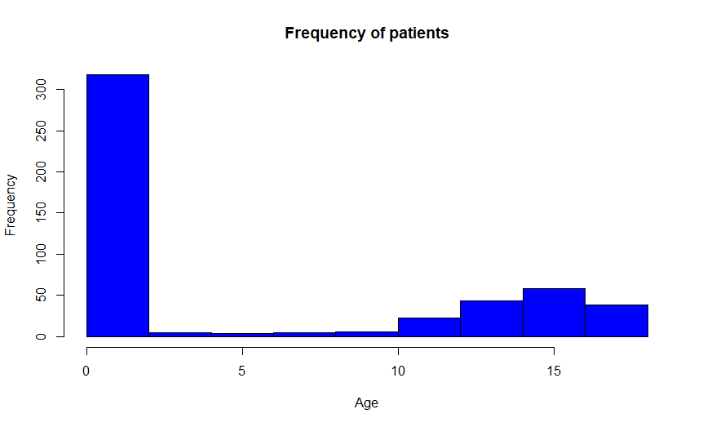

After that we will factor function and make the “AGE” column numerical which will be later used in summary

**attach(HealthDetails)**

**AGE=as.factor(AGE)**

**summary(AGE)**

0 1 2 3 4 5 6 7 8 9 10 11 12 13 14 15 16 17

307 10 1 3 2 2 2 3 2 2 4 8 15 18 25 29 29 38

**Conclusion:** From the above results we conclude that infant category has the max hospital visits (above 300). The summary of Age gives us the exact numerical output showing that Age 0 patients have the max visits followed by Ages 15-17

Aggregate function is used to add the expenditure from each age and then max function used to find highest costs.

**aggregate(TOTCHG~AGE,FUN=sum,data = HealthDetails)**

AGE TOTCHG

0 678118

1 37744

2 7298

3 30550

4 15992

5 18507

6 17928

7 10087

8 4741

9 21147

10 24469

11 14250

12 54912

13 31135

14 64643

15 111747

16 69149

17 174777

> max(aggregate(TOTCHG~AGE,FUN=sum,data = HealthDetails))

[1] 678118

**Conclusion:**Thus, we can also conclude that the infants have the maximum hospital costs followed by Age groups 15 -17, additionally we can say that number of hospital visits are proportional to hospital costs.

1. In order of severity of the diagnosis and treatments and to find out the expensive treatments, the agency wants to find the diagnosis-related group that has maximum hospitalization and expenditure.

**hist(APRDRG,col = "cyan1",main = "Frequency of the Treatments",xlab = "Treatment Categories")**

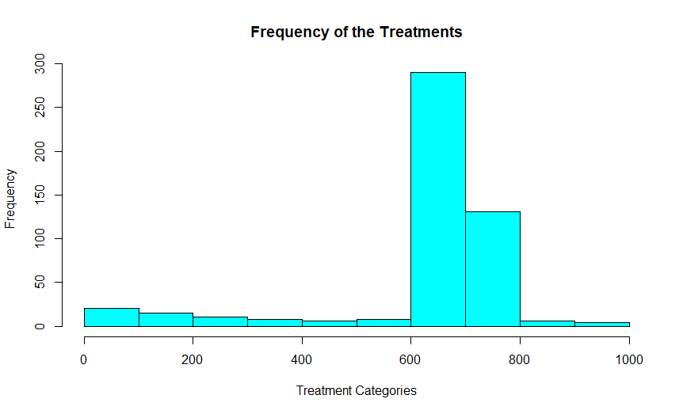

Now we will make the column(“APRDRG”) numerical and then generate a summary along with the which.max function to generate the max index of the category data frame, this will be followed by aggregate function.

> APRDRG_factor<-as.factor(HealthDetails$APRDRG)

> summary(APRDRG_factor)

21 23 49 50 51 53 54 57 58 92 97 114 115 137 138 139 141 143 204 206 225 249 254 308 313 317 344 347 420 421

1 1 1 1 1 10 1 2 1 1 1 1 2 1 4 5 1 1 1 1 2 6 1 1 1 1 2 3 2 1

422 560 561 566 580 581 602 614 626 633 634 636 639 640 710 720 723 740 750 751 753 754 755 756 758 760 776 811 812 863

3 2 1 1 1 3 1 3 6 4 2 3 4 267 1 1 2 1 1 14 36 37 13 2 20 2 1 2 3 1

911 930 952

1 2 1

> which.max(summary(APRDRG_factor))

640

44

> agg=aggregate(TOTCHG~APRDRG,FUN = sum,data=HealthDetails)

> agg

APRDRG TOTCHG

1 21 10002

2 23 14174

3 49 20195

4 50 3908

5 51 3023

6 53 82271

7 54 851

8 57 14509

9 58 2117

10 92 12024

11 97 9530

12 114 10562

13 115 25832

14 137 15129

15 138 13622

16 139 17766

17 141 2860

18 143 1393

19 204 8439

20 206 9230

21 225 25649

22 249 16642

23 254 615

24 308 10585

25 313 8159

26 317 17524

27 344 14802

28 347 12597

29 420 6357

30 421 26356

31 422 5177

32 560 4877

33 561 2296

34 566 2129

35 580 2825

36 581 7453

37 602 29188

38 614 27531

39 626 23289

40 633 17591

41 634 9952

42 636 23224

43 639 12612

44 640 437978

45 710 8223

46 720 14243

47 723 5289

48 740 11125

49 750 1753

50 751 21666

51 753 79542

52 754 59150

53 755 11168

54 756 1494

55 758 34953

56 760 8273

57 776 1193

58 811 3838

59 812 9524

60 863 13040

61 911 48388

62 930 26654

63 952 4833

> agg[which.max(agg$TOTCHG),]

APRDRG TOTCHG

44 640 437978

**Conclusion:** Hence can conclude that category 640 has the maximum hospitalizations along with this it also has the highest hospitalization cost.

1. To make sure that there is no malpractice, the agency needs to analyze if the race of the patient is related to the hospitalization costs.

We will first remove the Null values from our database, then factorize the RACE variable to generate a summary, additionally to verify whether race made an impact on the hospital costs we will use ANOVA function with TOTCHG as dependent variable and RACE as grouping variable.

HealthDetails=na.omit(HealthDetails)

> HealthDetails$RACE=as.factor(HealthDetails$RACE)

> model=aov(TOTCHG~RACE,data = HealthDetails)

> model

Call:

aov(formula = TOTCHG ~ RACE, data = HealthDetails)

Terms:

RACE Residuals

Sum of Squares 18593279 7523518505

Deg. of Freedom 5 493

Residual standard error: 3906.493

Estimated effects may be unbalanced

> summary(model)

Df Sum Sq Mean Sq F value Pr(>F)

RACE 5 1.859e+07 3718656 0.244 0.943

Residuals 493 7.524e+09 15260687

> summary(HealthDetails$RACE)

1 2 3 4 5 6

484 6 1 3 3 2

**Conclusion:** F value is quite low, which means that variation between hospital costs among different races is much smaller than the variation of hospital costs within each race, and P value being quite high shows that there is no relationship between race and hospital costs, thereby accepting the Null hypothesis.

1. To properly utilize the costs, the agency has to analyze the severity of the hospital costs by age and gender for the proper allocation of resources.

Now to analyse the severity of costs we will use linear regression with TOTCHG(Cost) and independent variable along with AGE and FEMALE as dependent variables

**HealthDetails$FEMALE=as.factor(HealthDetails$FEMALE)**

**regression=lm(TOTCHG~AGE+FEMALE,data = HealthDetails)**

> summary(regression)

Call:

lm(formula = TOTCHG ~ AGE + FEMALE, data = HealthDetails)

Residuals:

Min 1Q Median 3Q Max

-3403 -1444 -873 -156 44950

Coefficients:

Estimate Std. Error t value Pr(>|t|)

(Intercept) 2719.45 261.42 10.403 < 2e-16 ***

AGE 86.04 25.53 3.371 0.000808 ***

FEMALE1 -744.21 354.67 -2.098 0.036382 *

---

Signif. codes: 0 ‘***’ 0.001 ‘**’ 0.01 ‘*’ 0.05 ‘.’ 0.1 ‘ ’ 1

Residual standard error: 3849 on 496 degrees of freedom

Multiple R-squared: 0.02585, Adjusted R-squared: 0.02192

F-statistic: 6.581 on 2 and 496 DF, p-value: 0.001511

> summary(HealthDetails$FEMALE)

0 1

244 255

**Conclusion**-Age has more impact than gender according to the P-values and significant levels, also there are equal number of Females and Males and on an average (based on the negative coefficient values) females incur lesser hospital costs than males.

1. Since the length of stay is the crucial factor for inpatients, the agency wants to find if the length of stay can be predicted from age, gender, and race.

Using linear Regression(linear model), we can show whether length of stay is dependent on age, gender or race. Here we LOS is the dependent variable and age, gender and race are independent variables

> HealthDetails$RACE=as.factor(HealthDetails$RACE)

> model_linear=lm(LOS~AGE+FEMALE+RACE,data = HealthDetails)

> summary(model_linear)

Call:

lm(formula = LOS ~ AGE + FEMALE + RACE, data = HealthDetails)

Residuals:

Min 1Q Median 3Q Max

-3.211 -1.211 -0.857 0.143 37.789

Coefficients:

Estimate Std. Error t value Pr(>|t|)

(Intercept) 2.85687 0.23160 12.335 <2e-16 ***

AGE -0.03938 0.02258 -1.744 0.0818 .

FEMALE1 0.35391 0.31292 1.131 0.2586

RACE2 -0.37501 1.39568 -0.269 0.7883

RACE3 0.78922 3.38581 0.233 0.8158

RACE4 0.59493 1.95716 0.304 0.7613

RACE5 -0.85687 1.96273 -0.437 0.6626

RACE6 -0.71879 2.39295 -0.300 0.7640

---

Signif. codes: 0 ‘***’ 0.001 ‘**’ 0.01 ‘*’ 0.05 ‘.’ 0.1 ‘ ’ 1

Residual standard error: 3.376 on 491 degrees of freedom

Multiple R-squared: 0.008699, Adjusted R-squared: -0.005433

F-statistic: 0.6156 on 7 and 491 DF, p-value: 0.7432

**Conclusion:** p-values for all independent variables are quite high thus signifying that there is no linear relationship between the given variables, finally concluding the fact that we can’t predict length of stay of a patient based on age, gender and race.

1. To perform a complete analysis, the agency wants to find the variable that mainly affects hospital costs.

Using linear Regression, we can show which variable affects the hospital costs the most, thus TOTCHG becomes dependent variable and rest all variables will be independent.

**model_cost=lm(TOTCHG~., data = HealthDetails)**

**summary(model_cost)**

Call:

lm(formula = TOTCHG ~ ., data = HealthDetails)

Residuals:

Min 1Q Median 3Q Max

-6367 -691 -186 121 43412

Coefficients:

Estimate Std. Error t value Pr(>|t|)

(Intercept) 5024.9610 440.1366 11.417 < 2e-16 ***

AGE 133.2207 17.6662 7.541 2.29e-13 ***

FEMALE1 -392.5778 249.2981 -1.575 0.116

LOS 742.9637 35.0464 21.199 < 2e-16 ***

RACE2 458.2427 1085.2320 0.422 0.673

RACE3 330.5184 2629.5121 0.126 0.900

RACE4 -499.3818 1520.9293 -0.328 0.743

RACE5 -1784.5776 1532.0048 -1.165 0.245

RACE6 -594.2921 1859.1271 -0.320 0.749

APRDRG -7.8175 0.6881 -11.361 < 2e-16 ***

---

Signif. codes: 0 ‘***’ 0.001 ‘**’ 0.01 ‘*’ 0.05 ‘.’ 0.1 ‘ ’ 1

Residual standard error: 2622 on 489 degrees of freedom

Multiple R-squared: 0.5544, Adjusted R-squared: 0.5462

F-statistic: 67.6 on 9 and 489 DF, p-value: < 2.2e-16

**Conclusion:** Age and length of stay affect the total hospital costs.